**Research Supervisors**

**AY 2021-22**

|  |  |  |  |  |  |
| --- | --- | --- | --- | --- | --- |
| **S.No** | **Name of the Research supervisor** | **Department** | **Area of Specialization** | **Name of the**  **Scholar** | **Weblink for**  **Allotment Order** |
| 1 | Dr. Rayudu V V Krishna | ECE | Image Processing | Padala Ramesh Kumar | [View Document](http://acet.ac.in/ACET/AQAR/3.1.2/3.1.2_rvvk.pdf) |
| Mr.P Srinivas | [View Document](http://acet.ac.in/ACET/AQAR/3.1.2/3.1.2_rvvk2.pdf) |
| 2 | Dr. V Vijayasri Bolisetty | ECE | Wireless Communication | Mr.R.Lal Raja Lokesh Babu | [View Document](http://acet.ac.in/ACET/AQAR/3.1.2/3.1.2_bv.pdf) |

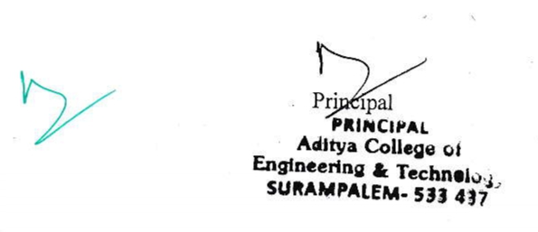Web Link:

<http://www.acet.ac.in/?p=Research_Supervisors>